Welcome to Magic City Chiropractic and Wellness

Patient Name:_____________________________________________ Today’s Date:_____________________

Address:_____________________________________________________________________________________

City: ________________________ State:______ Zip:__________ E-Mail:_____________________________

Phone: Home (____) _____ - ______ Work: (____) ____ - _______ Cell #: (____) _____ - ______

Birthdate: ___/___/_____ Age: _____ Social Security #: ____-____-______

Emergency contact name: ____________________ Phone number: _______________________________

How would you rate your overall Health? □ Excellent □ Very Good □ Good □ Fair □ Poor

Occupation: ______________________________ Employer: ______________________________________

Employer’s address: ____________________________________________________________________________

Name & Address of your physician ________________________________________________________________

May we have your permission to update your medical doctor regarding your care at this office? □ Yes □ No

Have you been to a chiropractor before? Y/N If yes, last time you went _________________________

INSURANCE INFORMATION*
*Please complete this section in full if you are covered by insurance or are entitled to receive benefit payments

This information will assist us in helping you to obtain the benefits to which you may be entitled.
Name of Insured ______________________________________ Insured’s Date of Birth __________________

Insured’s Address ________________________________________________________________________________

Insured’s Employer _____________________________________________________________________________

Primary Insurance Company Name ________________________________________________________________

Policy Number _______________________________________ Group ___________________________________

Secondary Insurance Company (if any) _____________________________________________________________

Type: □ Group □ Private □ Workman’s Comp □ Automobile

PATIENT CERTIFICATION AND SIGNATURE
I certify that the above information is true and correct. I hereby authorize the release of any information required to secure payment for services rendered. I authorize and direct that any insurance or medical coverage benefit payments shall be paid directly to Magic City Chiropractic and Wellness. I also understand benefits not covered by my insurance will be billed to me personally for which I will pay Magic City Chiropractic and Wellness.
The patient understands and agrees to allow this chiropractic office to use their Patient Health Information for the purpose of treatment, payment, healthcare operations, and coordination of care. We want you to know how your Patient Health Information is going to be used in this office and your rights concerning those records. If there is anyone you do not want to receive your medical records, please inform our office.

Our policy requires payment in full for all services rendered at the time of visit.

Patient’s Signature _______________________________________________________ Date: _______________

Guardian’s Signature Authorizing Care ________________________________________ Date: _______________

HISTORY OF PRESENT AND PAST ILLNESS:

Purposes of this appointment:

Chief Complaint: 1. _______________________________________ 2._______________________________________

Indicate on the drawings below where you have pain/symptoms

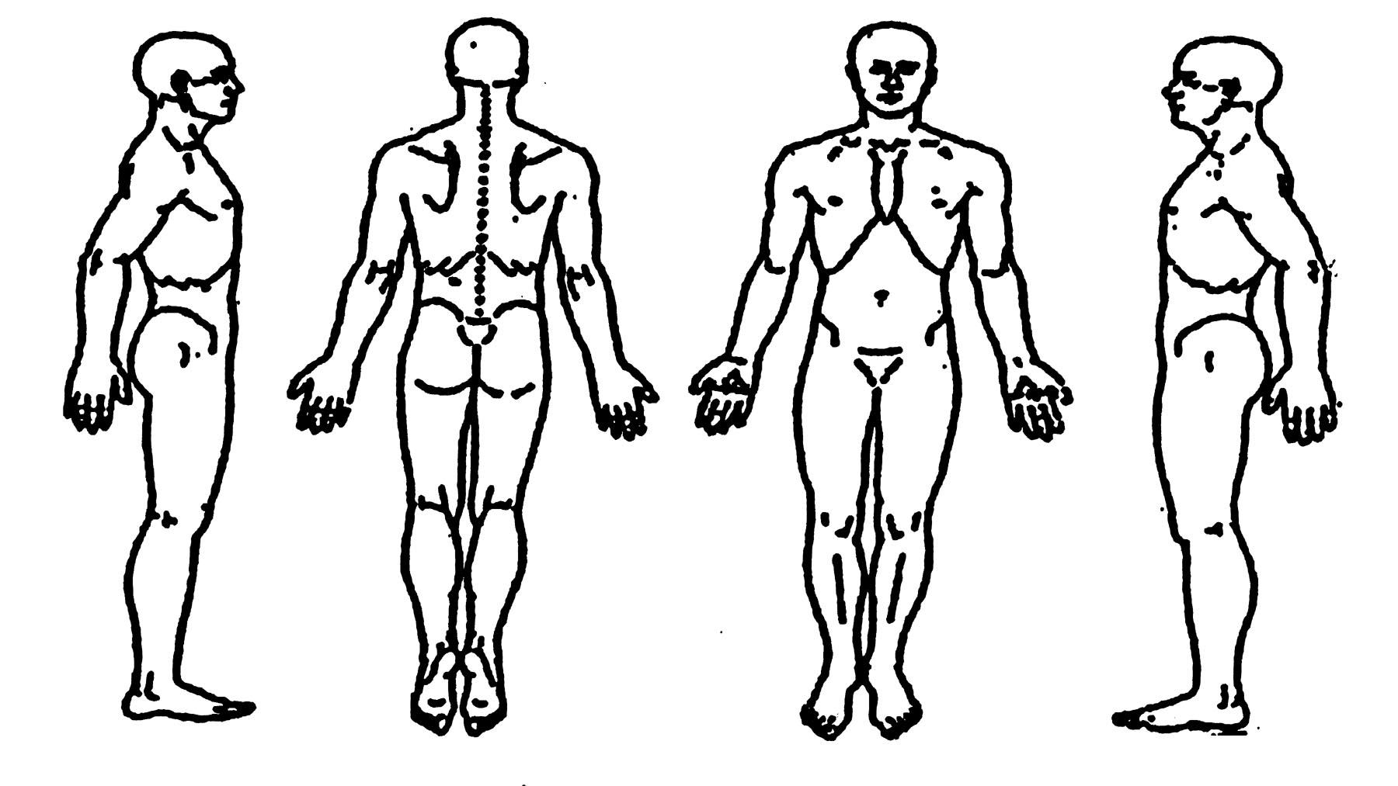
How long have you had this/these problem(s)? _______________________________________________________

How do you think your problem(s) began? ___________________________________________________________

Do you consider this problem to be severe? □ Yes □ Yes, at times □ No

Does the pain radiate into your arms or legs? □ Yes □ No If yes, which? _______________________________

How often do you experience your symptoms?
□ 76-100% of the time □ 26-50% of the time □ 51-75% of the time □ 1-25% of the time

How are your symptoms changing with time?
□ Getting Worse □ Staying the Same □ Getting Better

How would you describe the type of pain?
□ Sharp □ Dull □ Tightness □ Numbness □ Tingling □ Aching □ Burning □ Stabbing

What makes your problem worse? □ Sitting □ Standing □ Lying □ Bending □ Twisting □ Other ______________

Does anything make it feel better? _________________________________________________________________

Using a scale from 0-10 (10 being the worst), how would you rate your problem?
0 1 2 3 4 5 6 7 8 9 10 (Please circle)

How much has the problem interfered with your work?
□ Not at all □ A little bit □ Moderately □ Quite a bit □ Extremely

How much has the problem interfered with your social activities?
□ Not at all □ A little bit □ Moderately Quite a bit □ Extremely

Who else have you seen for your problem? □ Yes □ No If yes, who? _________________________________

Have you had same or similar problem(s) before? □ Yes □ No If yes, how long? __________________

How long were you treated? ___________________ What were the results? ____________________

Indicate if you have any immediate family members with any of the following:
□ Rheumatoid Arthritis □ Diabetes □ Lupus
□ Heart Problems □ Cancer □ ALS
□ Other ____________________________________________________

For each of the conditions listed below, place a check in the "past" column if you have had the condition in the past. If you presently have a condition listed below, place a check in the "present" column.

Past Present
( ) ( ) Headaches
( ) ( ) Neck Pain
( ) ( ) Upper Back Pain
( ) ( ) Mid Back Pain
( ) ( ) Low Back Pain
( ) ( ) Shoulder Pain
( ) ( ) Elbow/Upper Arm Pain
( ) ( ) Wrist Pain
( ) ( ) Hand Pain
( ) ( ) Hip Pain
( ) ( ) Upper Leg Pain
( ) ( ) Knee Pain
( ) ( ) Ankle/Foot Pain
( ) ( ) Jaw Pain
( ) ( ) Joint Pain/Stiffness
( ) ( ) Arthritis
( ) ( ) Rheumatoid Arthritis
( ) ( ) Cancer
( ) ( ) Tumor
( ) ( ) Asthma
( ) ( ) Chronic Sinusitis
Past Present
( ) ( ) High Blood Pressure
( ) ( ) Heart Attack
( ) ( ) Chest Pains
( ) ( ) Stroke
( ) ( ) Angina
( ) ( ) Kidney Stones
( ) ( ) Kidney Disorders
( ) ( ) Bladder Infection
( ) ( ) Painful Urination
( ) ( ) Loss of Bladder Control
( ) ( ) Prostate Problems
( ) ( ) Abnormal Weight Gain/Loss
( ) ( ) Loss of Appetite
( ) ( ) Abdominal Pain
( ) ( ) Ulcer
( ) ( ) Hepatitis
( ) ( ) Liver/Gall Bladder Disorder
( ) ( ) General Fatigue
( ) ( ) Muscular Incoordination
( ) ( ) Visual Disturbances
( ) ( ) Dizziness
Past Present
( ) ( ) Diabetes
( ) ( ) Excessive Thirst
( ) ( ) Frequent Urination
( ) ( ) Smoking/Tobacco Use
( ) ( ) Drug/Alcohol Dependence
( ) ( ) Allergies
( ) ( ) Depression
( ) ( ) Systemic Lupus
( ) ( ) Epilepsy
( ) ( ) Dermatitis/Eczema/Rash
( ) ( ) HIV/AIDS

For Females Only
( ) ( ) Birth Control Pills
( ) ( ) Hormonal Replacement
( ) ( ) Pregnancy

( ) ( ) Other:__________________________________________________________

Do you have a history of stroke or hypertension? _____________________________________________________

Have you been treated for any health condition by a physician in the last year? □ Yes □ No
If yes, please describe: ___________________________________________________________

List all prescription medications you are currently taking: ______________________________________

List all of the over-the-counter medications you are currently taking:
________________________________________________________________________________

List all major illnesses, injuries, falls, auto accidents or surgeries you have had (include dates):
________________________________________________________________________________

What activities do you do at work?
□ Sit: □ Most of the day □ Half the day □ A little of the day
□ Stand: □ Most of the day □ Half the day □ A little of the day
□ Computer work: □ Most of the day □ Half the day □ A little of the day
□ On the phone: □ Most of the day □ Half of the day □ A little of the day

What activities do you do outside of work? __________________________________________________

Females, is there any chance you are pregnant? □ Yes □ No

INFORMED CONSENT
Informed consent is more than just a signed document. The following categories will be or have been discussed.
- What’s wrong? Or your diagnosis
- What tests will be ordered; the reason for them; and results expected to achieve.
- Whether or not Chiropractic can be helpful in this case.
- Alternative treatments and your options.
- A treatment plan outlined for your case with expected time frame for results
- Cost of this treatment

These categories have been discussed with me in my report of findings; and I am authorizing Dr. Scott Albano to treat my conditions within the parameters outlined, to the best of his ability. I also give Magic City Chiropractic and Wellness the permission to discuss my medical findings, care, and treatment plan to referring doctors if needed.

Patient’s Signature _________________________________________________ Date _____________________

